# C2- S5 - PRACTICE

*NOTE: check your* ***THEORY slides*** *to answer those questions!*

# EXERCISE 1 – GOOGLE CLASSROOM DATABASE

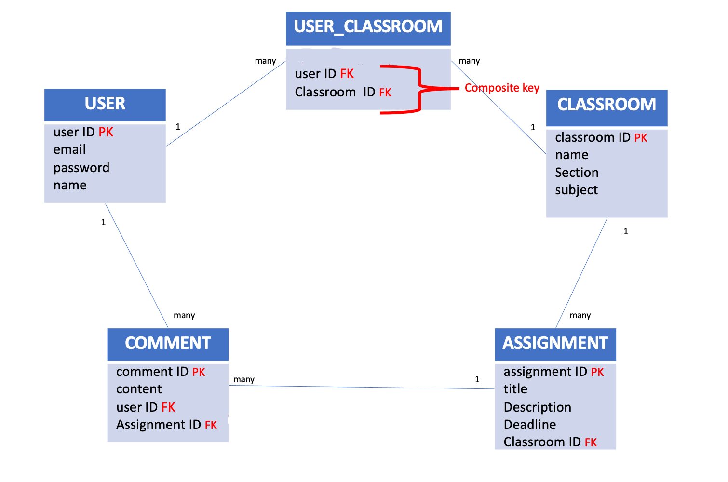

Here is the Entity Relation Diagram of the Google Classroom Database you designed in Chapter 1. You are now going to put it in MySQL!

**Q1 –** Write a statement to create the google classroom database, and to tell MySQL you are now working with it.

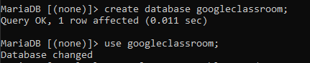

**Q2** – For each table (USER, USER_CLASSROOM, CLASSROOM, ASSIGNMENT, COMMENT),complete the following arrays, by specifying for each attribute:

* + The attribute type (SQL type) and size
  + Can be null or not?
  + Is a primary key or foreign keys?
* **USER TABLE**

|  |  |  |  |
| --- | --- | --- | --- |
| Attribute name | Type / size | Can be Null? | Key |
| UserID | int | Not null | Primary key |
| name | Varchar(100) | Not null |  |
| email | Varchar(100) | Null |  |
| password | Varchar(100) | Null |  |

**USER_CLASSROOM TABLE**

|  |  |  |  |
| --- | --- | --- | --- |
| Attribute name | Type / size | Null? | Key |
| User ID | Int | NOT NULL | Foreign key |
| Classroom ID | Int | NOT NULL | Foreign key |

**CLASSROOM TABLE**

|  |  |  |  |
| --- | --- | --- | --- |
| Attribute name | Type / size | Null? | Key |
| Classroom ID | Int | Not null | Primary key |
| Name | Varchar(100) | Not null |  |
| Section | Varchar(100) | Null |  |
| Subject | Varchar(100) | Not null |  |

**ASSIGNMENT TABLE**

|  |  |  |  |
| --- | --- | --- | --- |
| Attribute name | Type / size | Null? | Key |
| Assignment ID | Int | Not null | Primary key |
| Title | Varchar(100) | Not null |  |
| Description | Varchar(255) | Null |  |
| Deadline | Date | Null |  |
| Classroom Id | int | Not null | Foreign key |

**COMMENT TABLE**

|  |  |  |  |
| --- | --- | --- | --- |
| Attribute name | Type / size | Null? | Key |
| Comment id | int | Not null | Primary key |
| Content | Varchar(255) | Not null |  |
| User Id | int | Not null | Foreign key |
| Assignment ID | Int | Not null | Foreign key |

**Q3** – Write the SQL statement to create the 5 tables with appropriate properties.

WARNING: Create the tables in the right order to respect the Foreign Key constraints.

USER TABLE

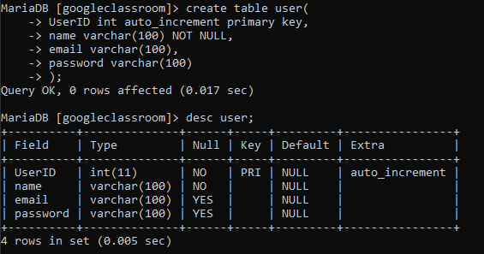

CLASSROOM TABLE

USER_CLASSROOM TABLE

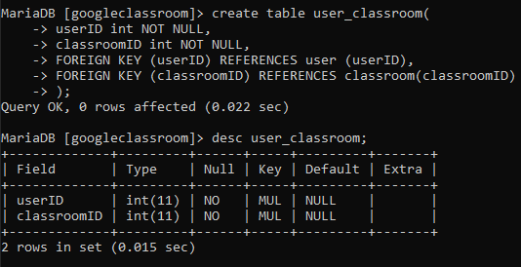

ASSIGNMENTT TABLE

COMMENT TABLE

**Q4 –** Write statements to insert at least 3 records in each table.

USER TABLE

CLASSROOM TABLE

USER_CLASSROOM TABLE

ASSIGNMENT TABLE

CONTENT TABLE

# EXERCISE 2 – FOODPANDA DATABASE

Here is the Entity Relation Diagram of the Foodpanda Database you designed in Chapter 1. You are now going to put it in MySQL!

**Q1 –** Write a statement to create the Foodpanda database, and to tell MySQL you are now working with it.

**Q2** – For each table of the database, complete the following array, by specifying for each attribute:

* + The attribute type (SQL type) and size
  + Can be null or not?
  + Is a primary key or foreign keys?

1. Address Table

|  |  |  |  |
| --- | --- | --- | --- |
| Attribute name | Type / size | Null? | Key |
| addressID | Int | Not NULL | Primary key |
| street | Varchar (100) | Not null |  |
| district | Varchar (100) | Not null |  |
| city | Varchar (100) | Not null |  |

1. Customers Table

|  |  |  |  |
| --- | --- | --- | --- |
| Attribute name | Type / size | Null? | Key |
| customerID | Int | NOT NULL | Primary key |
| customerName | Varchar (100) | NOT NULL |  |
| addressID | Varchar (100) | NULL | FOREIGN KEY |
| email | Varchar (100) | Null |  |
| phoneNumber | Varchar (100) | NOT NULL |  |

1. Deliverers Table:

|  |  |  |  |
| --- | --- | --- | --- |
| Attribute name | Type / size | Null? | Key |
| delivererID | int | NOT NULL | Primary key |
| phoneNumber | Varchar (100) | NOT NULL |  |
| vehicle | Varchar (100) | NULL |  |

1. Restaurants Table:

|  |  |  |  |
| --- | --- | --- | --- |
| Attribute name | Type / size | Null? | Key |
| restaurantID | Int | NOT NULL | Primary key |
| restaurantName | Varchar (100) | NOT NULL |  |
| addressID | Varchar (100) | NULL | Foreign key |
| website | Varchar (100) | NULL |  |
| phoneNumber | Varchar (100) | NOT NULL |  |
| category | Varchar (100) | NULL |  |

1. Food_items Table:

|  |  |  |  |
| --- | --- | --- | --- |
| Attribute name | Type / size | Null? | Key |
| mealID | Int | NOT NULL | Primary key |
| mealName | Varchar (100) | NOT NULL |  |
| unitPrice | Varchar (100) | NOT NULL |  |
| category | Varchar (100) | NOT NULL |  |
| restaurantID | Int | NULL | Foreign key |

1. Orders Table:

|  |  |  |  |
| --- | --- | --- | --- |
| Attribute name | Type / size | Null? | Key |
| orderID | int | NOT NULL | Primary key |
| customerID | Int | NOT NULL | Foreign key |
| orderdate | date | NOT NULL |  |
| pickUp | Varchar (100) | NULL |  |
| restaurantID | Int | NOT NULL | Foreign key |
| delivererID | int | NOT NULL | Foreign key |

1. Order food Table:

|  |  |  |  |
| --- | --- | --- | --- |
| Attribute name | Type / size | Null? | Key |
| mealID | Int | NOT NULL | Foreign key |
| orderID | int | NOT NULL | Foreign key |
| quantity | Int | NOT NULL |  |

**Q3** – Write the SQL statement to create the tables with appropriate properties.

WARNING: Create the tables in the right order to respect the Foreign Key constraints.

Address table

customers table

Deliverers table

Restaurants tables

Food items tables

Orders tables

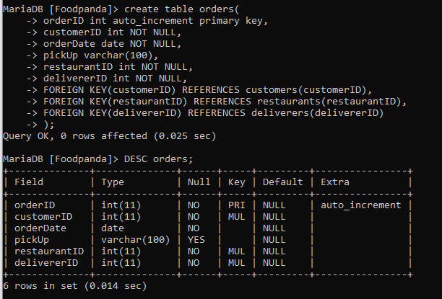

Order food table

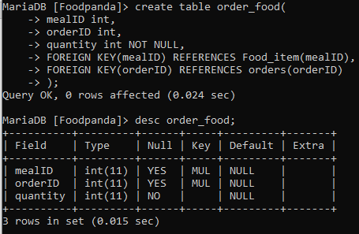

**Q4 –** Write statements to insert between 2 and 4 records in each table.

Address table

customers table

deliverers table

restaurant table

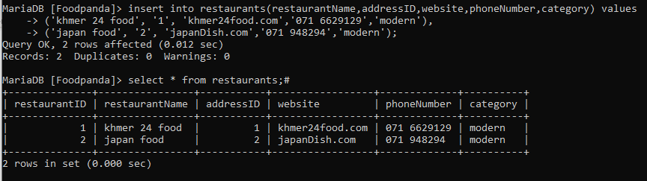

Food-item table

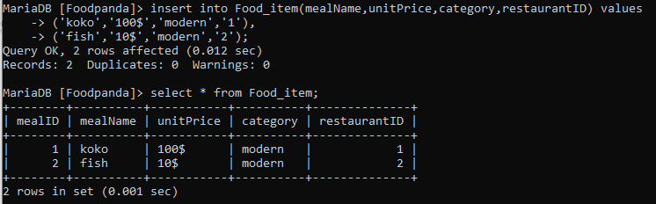

Order table

Order food table

